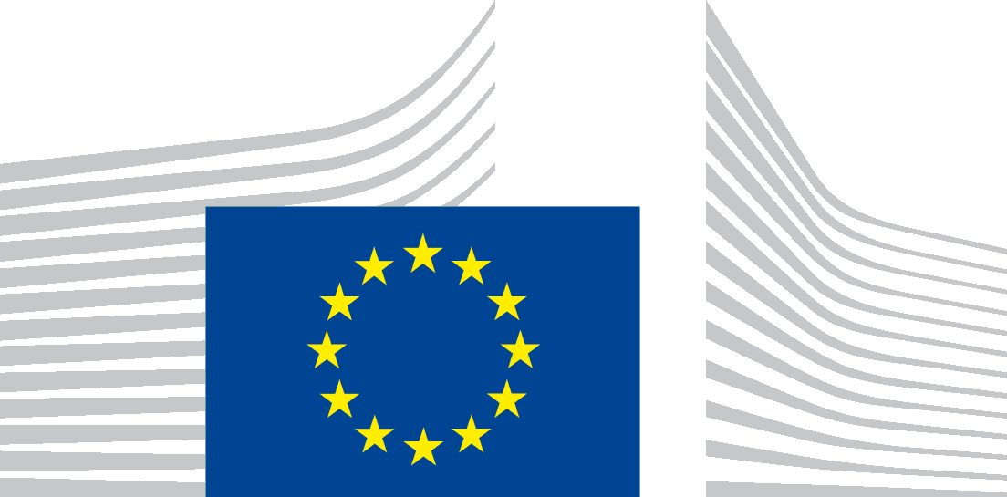 | EUROPEAN COMMISSION  DIRECTORATE-GENERAL FOR EDUCATION AND CULTURE  Modernisation of Education II: Education policy and programme, Innovation, EIT and MSCA  Higher education

NOTE FOR DISSEMINATION TO HIGHER EDUCATION INSTITUTIONS PARTICIPATING IN ERASMUS+

Follow-up of the webinar for higher education institutions on the inclusion of higher education students and staff with physical, mental or health-related conditions in the Erasmus+ programme (6 December 2016 at 10 am Brussels time)

Dear colleagues,

Following the webinar on the inclusion of higher education students and staff with physical, mental or health-related conditions in the Erasmus+ programme (6 December 2016), please find below the relevant materials of the session, for dissemination to higher education institutions.

- Link to the webinar recording - https://eu1.bbcollab.com/p.jnlp?psid=2016-12-06.0816.M.474888EA51EEDF8F52D991CD711A83.vcr&sid=2014023

- Webinar Presentation

- Recommendations for higher education institutions on the inclusion of higher education students and staff with physical, mental or health-related conditions in the Erasmus+ programme (December 2016 edition)

Thank you once again for your participation in the webinar.

Kind regards,

The EAC Higher Education & OLS Erasmus+ team
In cooperation with the Erasmus+ Higher Education Working Group on Special Needs / Persons with Disabilities

